Progress Report

The progress is a bit delayed due to examination but still satisfactory. The major parts of the game including management of generator, score counting, game judgment, information exchange are 90% done. *Satellite Hack* (mini game) is delayed but should be able to catch up the schedule. It is more than 60% done.

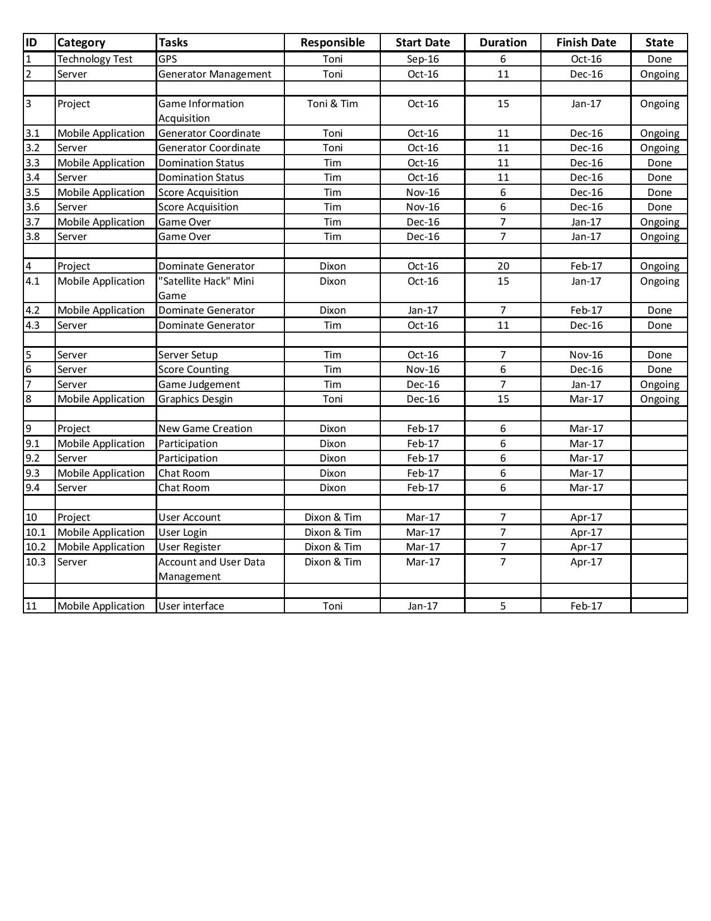Some other tasks have started earlier for the ease of development like account management, user interface.

